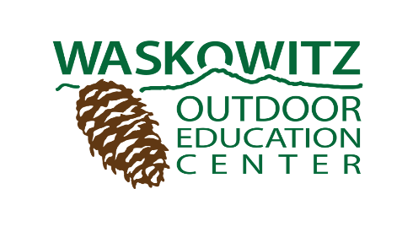
Waskowitz Outdoor School Covid-19 Safety Plan Highlights
Fall 2021
Waskowitz has been working closely with Washington State Department of Health and the Governor’s Office to ensure our safety plan includes the required safety practices to keep your student safe during their overnight outdoor education experience at Waskowitz.
To maximize student safety at outdoor school, Covid-safe practices include:
- All staff and teachers are fully vaccinated.
- All outdoor school students (6th grade and high school leaders) that are NOT fully vaccinated will be tested prior to arrival at Waskowitz. Batch PCR tests (grouped test results) and BinaxNOW rapid antigen test (results in 15 minutes) will be used. The testing will occur at the school prior to departing for Waskowitz.
- Students will have assigned seating on the bus and will wear masks. Windows will be down and vents open.
- Student meals will be served in the dining hall with windows down and socially distanced tables. Lunches on day two and three will be served outside.
- Students will sit at assigned tables with the same students for each meal.
- Students will sleep in a staggered configuration with alternating heads and feet at the wall. Windows will be open for ventilation, and air purification systems will keep fresh air flowing through dorms.
- Students will remain in a cohorts in cabins and dining. Your student’s cohort will join another cohort in a group similar to a regular class size for the instructional class time.

Masking for added safety
- Masks will be worn in all indoor spaces.
- While hiking, exploring, or investigating in the outdoors, masks are optional, per current state guidance. Student will be encouraged to choose their comfort level when outdoors. Individual decisions by staff and students to mask during outdoor activities will be supported and encouraged.
- We will practice social distancing during outdoor programs.
- Visitors will not be allowed on Waskowitz property during your students’ week at Waskowitz.
Extra Sanitation
- Caretakers have increased their cleaning and sanitizing routine using approved products.
- Each morning cabin leaders will conduct a COVID screen. If a student has any COVID symptoms, the student will be tested on site. If positive, they will be immediately isolated and parent/guardian will be called to pick up their student. Students in close contact with the positive student will be tested, and their families will be informed.
During summer 2021 Highline Public Schools and Waskowitz provided several safe overnight programs, following these procedures. Waskowitz also hosted programs run by other organizations by following our procedures. We are not aware of any COVID transmission during our programs. Waskowitz will not compromise on the safety of your student.
We are looking forward to welcoming your student to Waskowitz!

